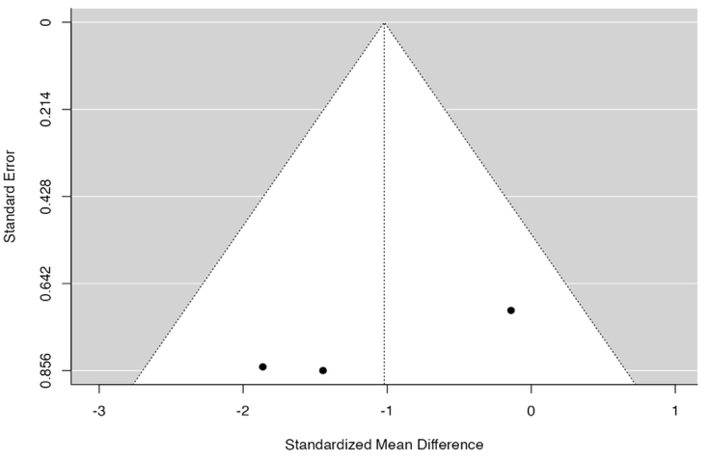
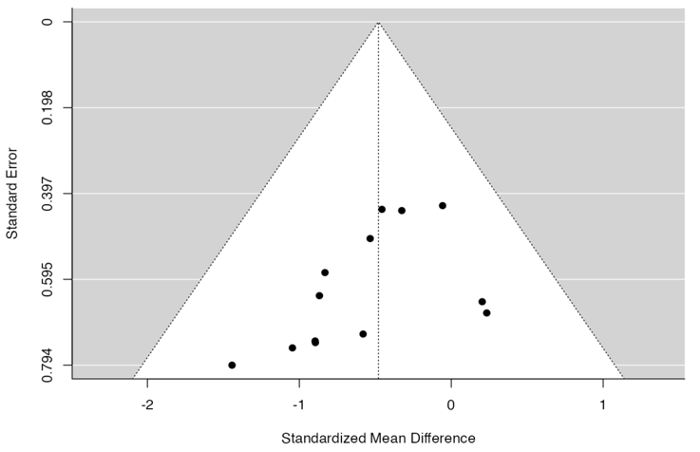
A Spleen HGP B Spleen Leuk

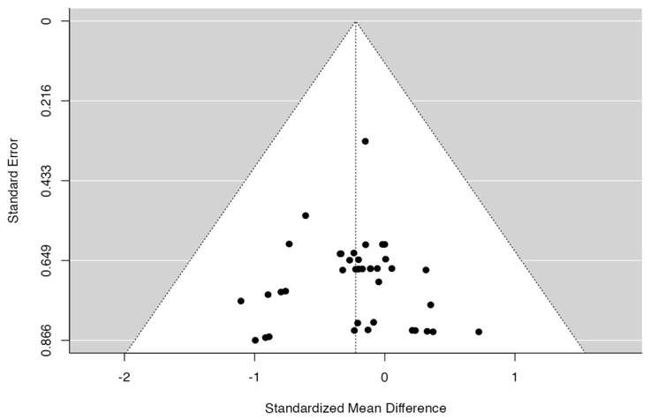
C PB HGP

Suppl 11: Funnel plot for subgroup disease targeted and HDR analysis. The correlation and regression coefficient of data provided for spleen engraftment (A) p=0.030, p=0.199 for HGP (B) p=1.000, p=0.107 for leukaemia. Data provided for PB engraftment (C) targeting HGP disease reveals neither the rank correlation nor the regression test indicated any funnel plot asymmetry (p =0.9539 and p = 0.9776, respectively).

