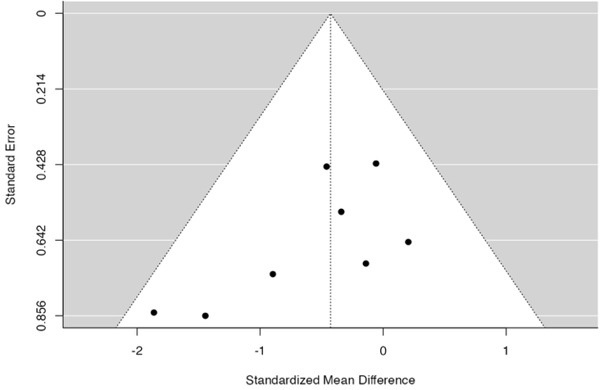
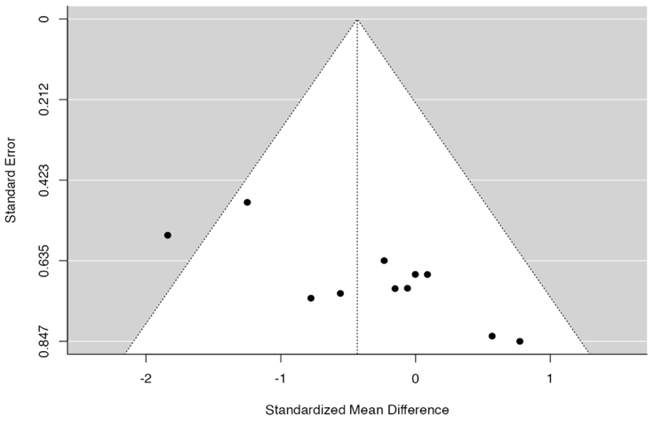
A BM Retro B Spleen Tail vein

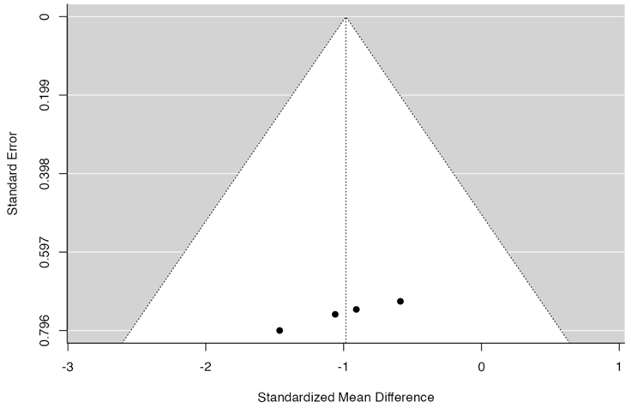
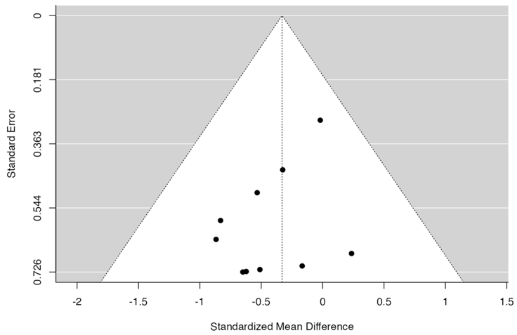
C Spleen Retro-orbital C Spleen Intraperitoneal

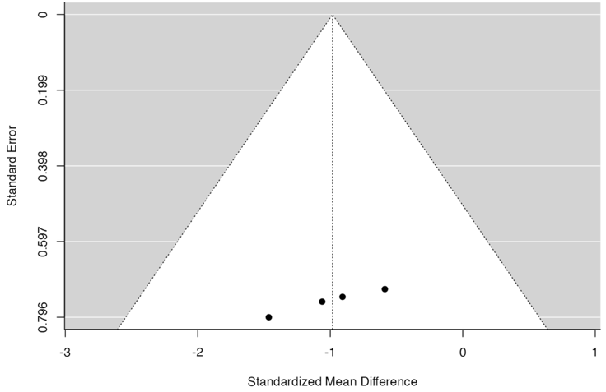
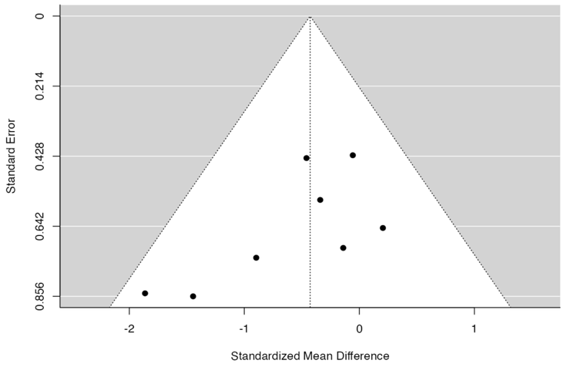
E PB Tail vein F PB Intraperitoneal

Suppl 9: Funnel plot for subgroup route of delivery analysis (A) for BM engraftment through retro-orbital route the regression test indicated funnel plot asymmetry (p = 0.0027) but not the rank correlation test (p = 0.1210). Data provided for spleen engraftment through different route of delivery are unbiased as suggested by correlation and regression coefficient respectively for (B) tail vein; p=0.109, p=0.109 (C) retro-orbital; p=0.381. p=0.280 (D) intraperitoneal; p=0.083, p=0.412. The correlation and regression coefficient of data provided for PB engraftment through (E) tail vein; p=0.013, p=0.247 (F) intraperitoneal; p=0.083, p=0.722.

