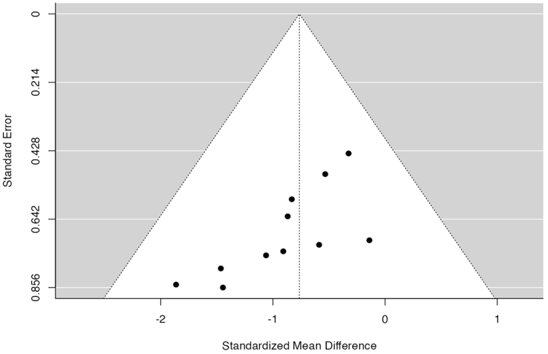
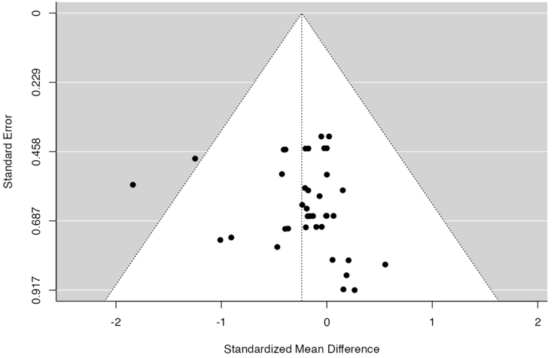
A BM NSG B Spleen NSG

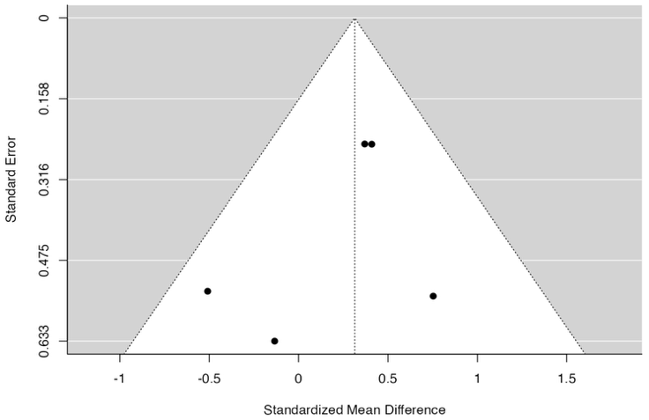
C PB NSGS

Suppl 8. Funnel plot of mice strain subgroup analysis. (A) BM engraftment using NSG mice strain reveals neither the rank correlation nor the regression test indicated any funnel plot asymmetry (p = 0.8222 and p = 0.6319, respectively). (B) for spleen engraftment using NSG mice the rank correlation test indicated funnel plot asymmetry (p = 0.0008) but not the regression test (p = 0.0861). (C) for PB using NSGS mice strain neither the rank correlation nor the regression test indicated any funnel plot asymmetry (p = 1.0000 and p = 0.3456, respectively).

