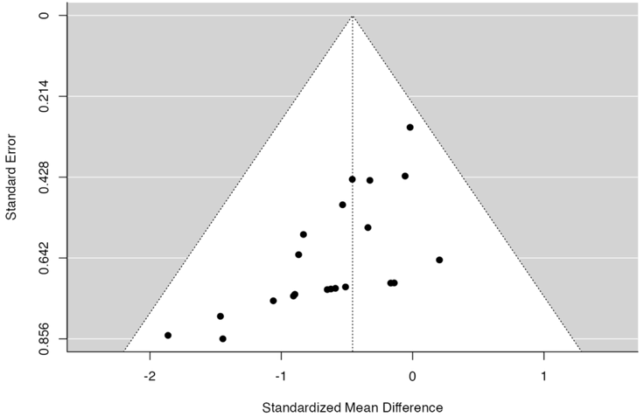
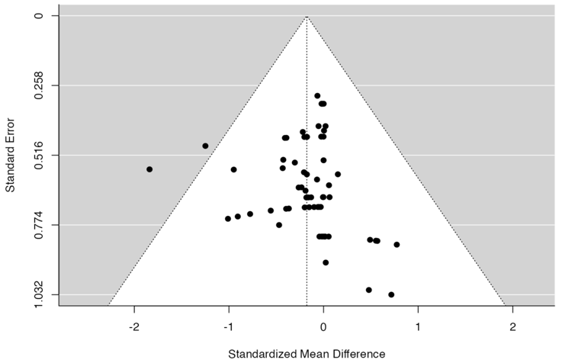
A BM B Spleen

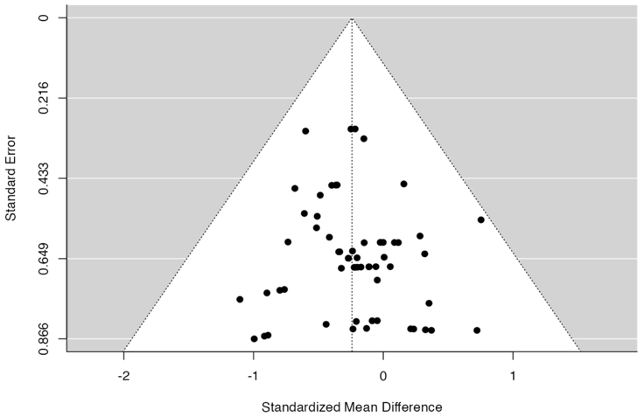
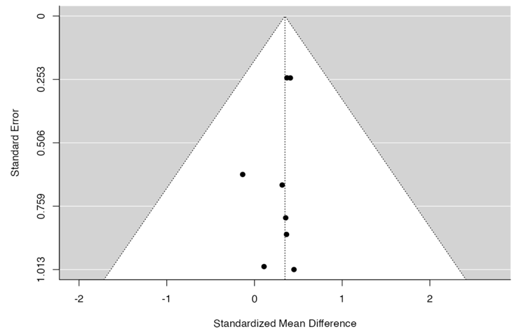
C PB RNP D PB RNA

Suppl 7. Funnel plot of subgroup for CRISPR system analysis. (A) For bone marrow, the rank correlation and the regression test indicated potential funnel plot symmetry (p=0.590 and p = 0.922, respectively) (B) For spleen engraftment the rank correlation and the regression test indicated potential funnel plot asymmetry (p < 0.001 and p = 0.012, respectively) (C) For peripheral blood the data for RNP provided the value for unbias as (Correlation p = 0.634 and Regression p = 0.548) (D) For PB engraftment data using RNA as CRISPR system neither the rank correlation nor the regression test indicated any funnel plot asymmetry (p = 0.9049 and p = 0.7042, respectively).

