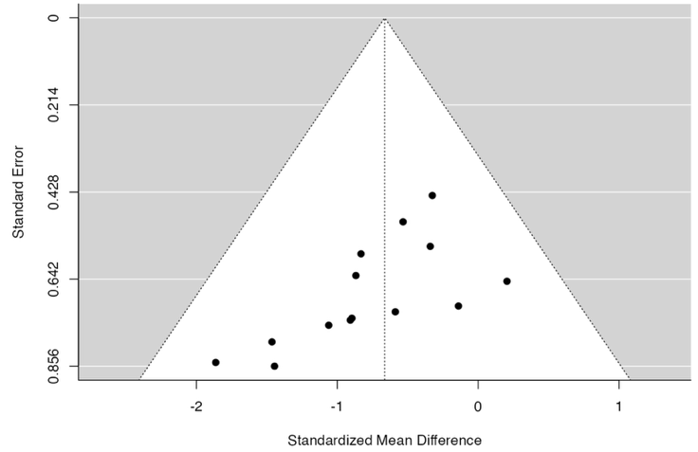
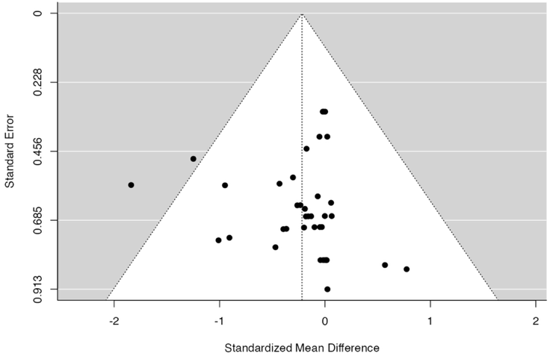
A BM B Spleen
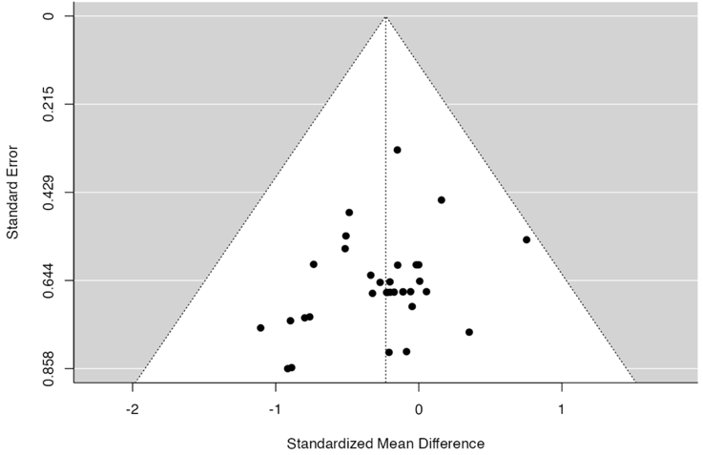

C PB

Suppl 6. Funnel plot of knockout subgroup analysis. (A) For bone marrow, the rank correlation and the regression test indicated potential funnel plot symmetry (p=0.920 and p = 0.758, respectively) (B) For spleen engraftment the rank correlation and the regression test indicated potential funnel plot asymmetry (p < 0.001 and p = 0.078, respectively) (C) For peripheral blood the data provided the value for bias as (Correlation p = 0.026 and Regression p = 0.330).

