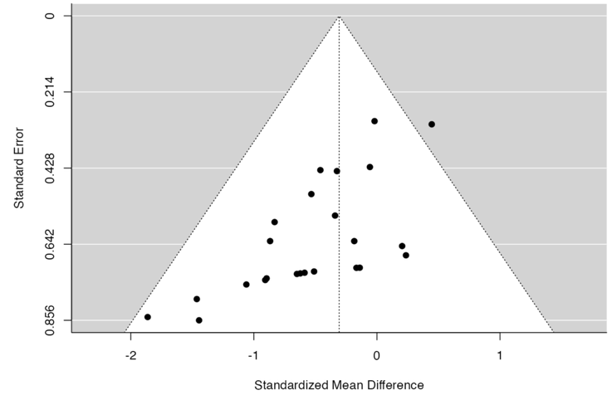
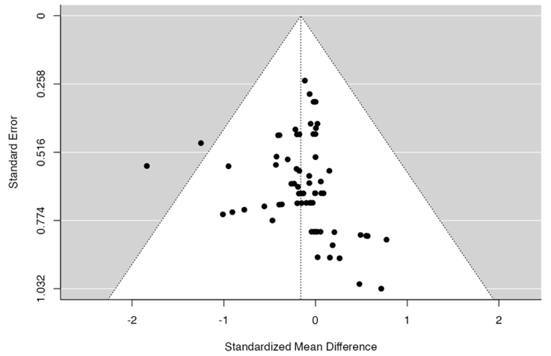
A BM B Spleen

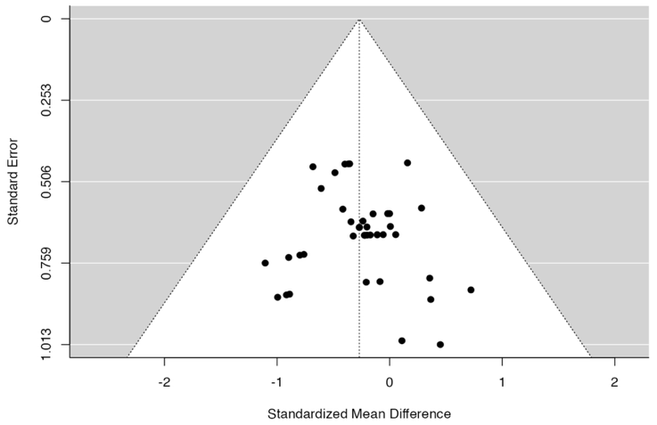
C PB

Suppl 2. Funnel plot for pooled analysis. (A) For bone marrow, the rank correlation and the regression test indicated potential funnel plot symmetry (p=0.1373 and p = 0.7823, respectively) (B) For spleen engraftment the rank correlation and the regression test indicated potential funnel plot asymmetry (p < 0.0001 and p = 0.0016, respectively) (C) For peripheral blood the data provided are homogenous without any bias (Correlation p = 0.9023 and Regression p = 0.7030).

