Suppl 11a. Sensitivity Analysis for Any Adverse Events. NCT identifiers correspond to: NCT01969838 – SIMPLIFY-1; NCT04173494 – MOMENTUM.
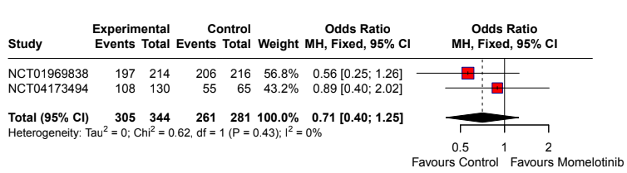

Suppl 11b. Sensitivity Analysis for Discontinuation Events. NCT identifiers correspond to: NCT02101268 – SIMPLIFY-2; NCT04173494 – MOMENTUM.
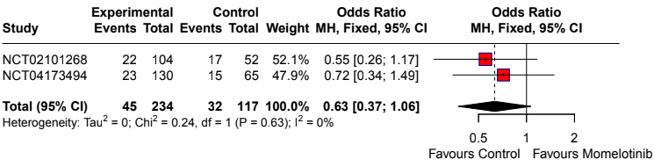
Suppl 11c. Sensitivity Analysis for Diarrhea. NCT identifiers correspond to: NCT02101268 – SIMPLIFY-2; NCT04173494 – MOMENTUM.
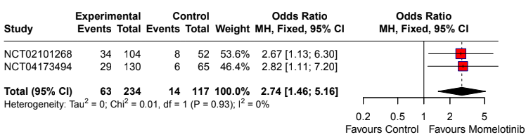

Suppl 11d. Sensitivity Analysis for Thrombocytopenia. NCT identifiers correspond to: NCT02101268 – SIMPLIFY-2; NCT04173494 – MOMENTUM.
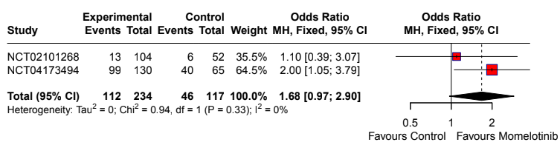

Suppl 11e. Sensitivity Analysis for Peripheral Neuropathy. NCT identifiers correspond to: NCT02101268 – SIMPLIFY-2; NCT01969838 – SIMPLIFY-1.
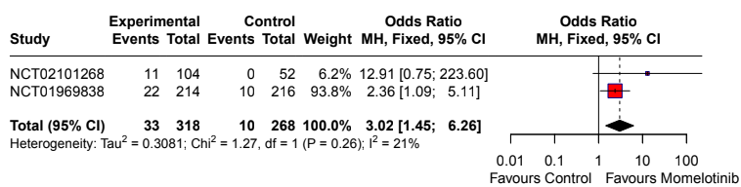
Suppl 11f. Sensitivity Analysis for Anemia. NCT identifiers correspond to: NCT02101268 – SIMPLIFY-2; NCT04173494 – MOMENTUM.
