Suppl 8a. Sensitivity Analysis for Splenic Response Rate. NCT identifiers correspond to: NCT01969838 – SIMPLIFY-1; NCT02101268 – SIMPLIFY-2.
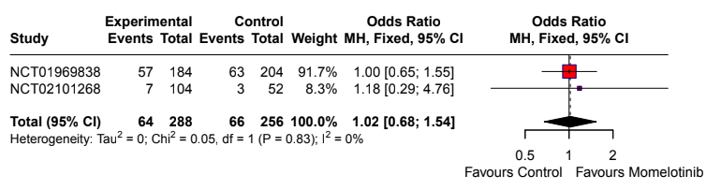
Suppl 8b. Sensitivity Analysis for TSS (Total Symptom Score) Response Rate. NCT identifiers correspond to: NCT02101268 – SIMPLIFY-2; NCT04173494 – MOMENTUM.
