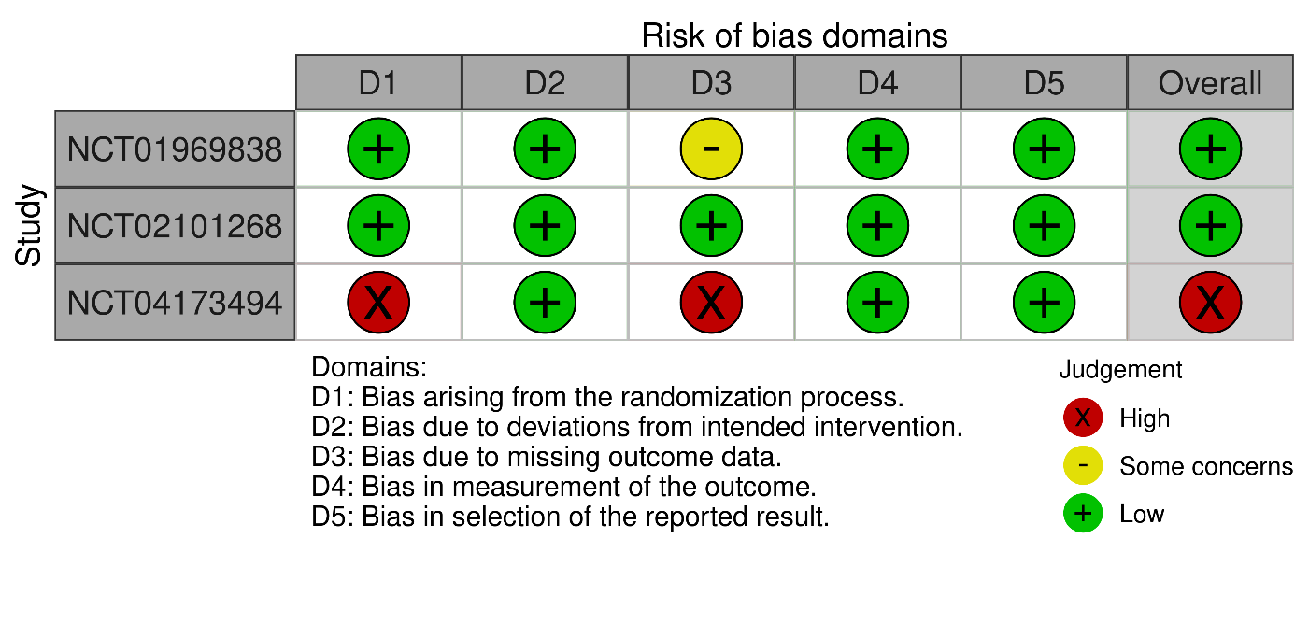
Suppl 2. Risk of Bias Assessment for Double-Arm Studies

