Suppl 5. Venn Diagram showing the intersections of the differentially expressed miRNAs from SAR1A-knockout K562 cells compared to wild type without or with HU treatment. Fifty-seven and twenty-four differentially expressed miRNAs were uniquely identified in SAR1A-knockout K562 cells without and with HU treatment, respectively. An additional 75 differentially expressed miRNAs were common among them.

+HU (99)
-HU (132)

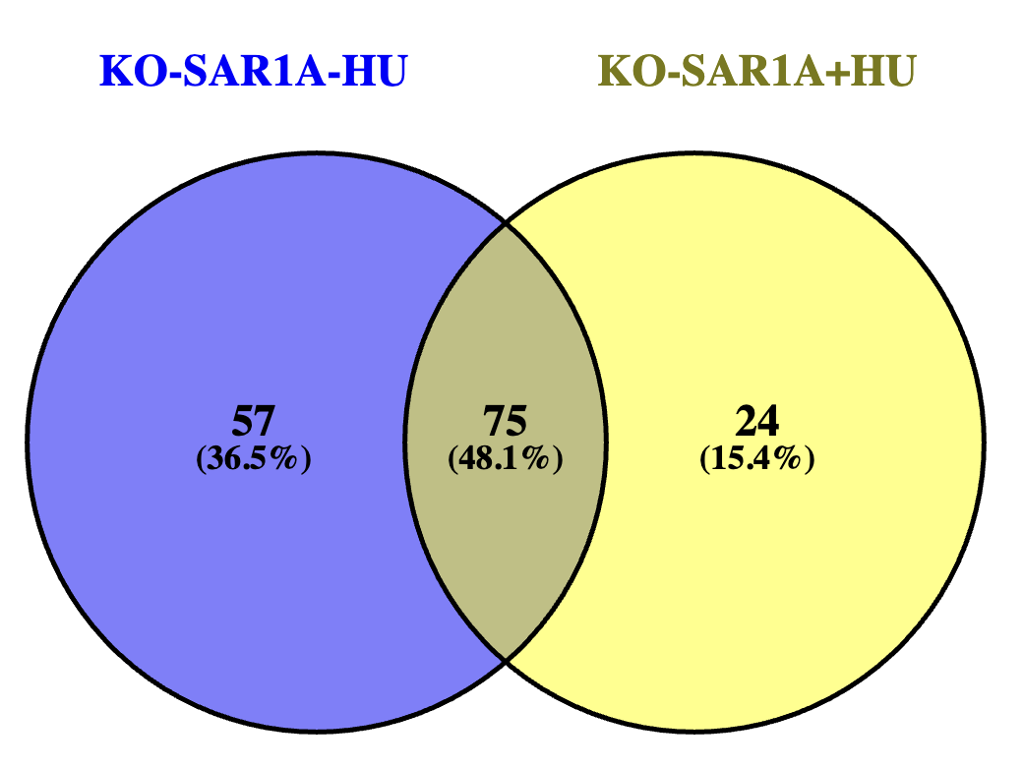

Suppl 5

