Supplementary 2. Knockout of the SAR1A gene reduces SAR1A mRNA and protein expression but does not rescue HbF induction during HU treatment. (a) K562 cells were transfected with GFP-tagged SAR1A-CRISPR/Cas9 knockout plasmid (SAR1A-KO) and positive clones were selected by adding 2 μg/mL of puromycin 24 h after transfection. The cells were cultured for 96 h and then treated with 100 μM of HU for 72 h. The SAR1A-KO K562 cells were measured as GFP⁺ cells by flow cytometry and are represented in histogram plots. K562 cells without transfection were used as an internal control and are indicated as wild type. (b) Mean percentages from flow cytometry analysis of GFP⁺ cells in K562 cells as described in (a). Error bars represent the standard deviation from 3 individual experiments. (c) Mean relative SAR1A gene expression levels in K562 cells as described in (a), shown as fold induction compared with non-transfected cells without HU treatment by qRT-PCR. Values were normalized to the expression level of the housekeeping gene GAPDH. Error bars represent the standard deviation from 3 individual experiments. (d) Whole-cell lysates from the K562 cells described in (a) were analyzed by Western blotting using antibodies targeting SAR1A and HbF. β-actin was used as an internal control. Blots are representative images of 3 independent experiments showing similar results.

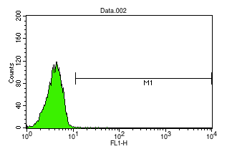
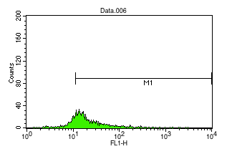
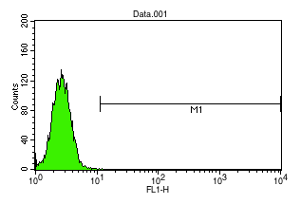
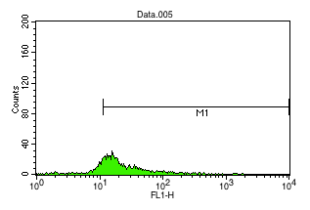
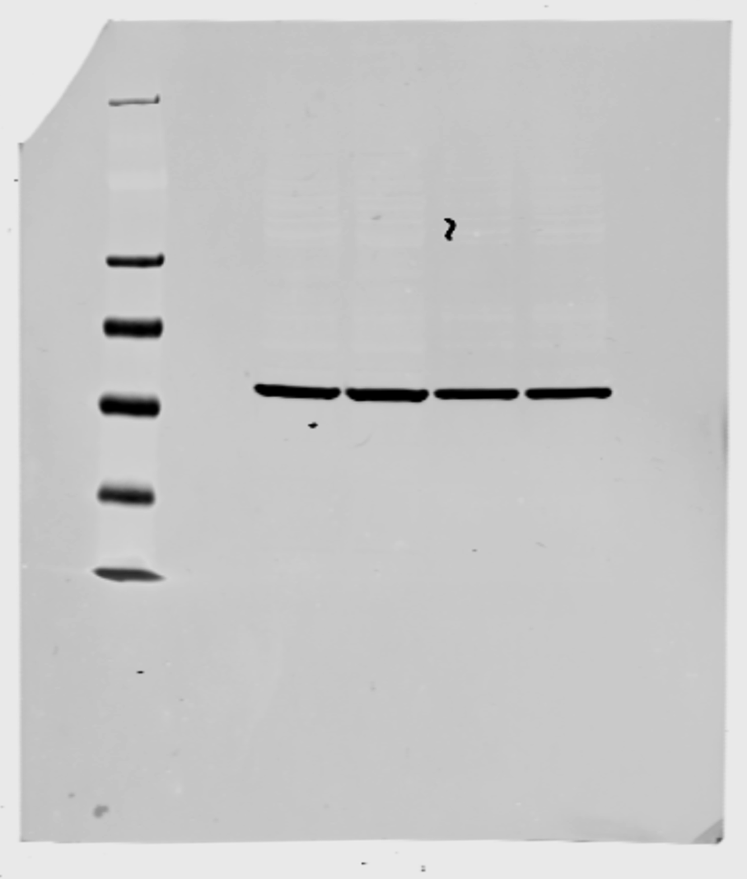
a
Number of GFP⁺ cells (%)
SAR1A-KO
-HU
+HU
0.01%
0.15%
80.76%
77.08%
Wild type
β-actin
HbF
SAR1A
SAR1A-KO - - + +
HU - + - +
HU - + - +
SAR1A-KO - - + +

b

c
d
Relative quantity of SAR1A expression
SAR1A-KO - - + +
HU - + - +

Suppl 2

