Suppl 10a. Forest Plot of Adverse Events Leading to Dose Reduction. NCT identifiers correspond to: NCT02101268 – SIMPLIFY-2; NCT01969838 – SIMPLIFY-1; NCT04173494 – MOMENTUM.
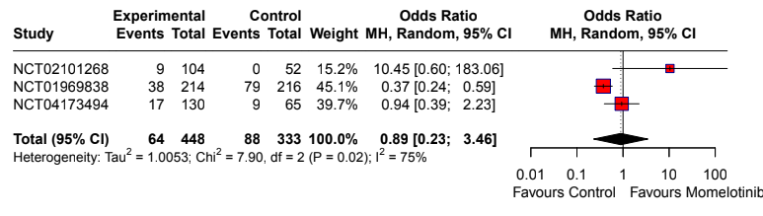

Suppl 10b. Forest Plot of Serious Adverse Events. NCT identifiers correspond to: NCT02101268 – SIMPLIFY-2; NCT01969838 – SIMPLIFY-1; NCT04173494 – MOMENTUM.
