Suppl 9a. Forest Plot of Any Adverse Events. NCT identifiers correspond to: NCT02101268 – SIMPLIFY-2; NCT01969838 – SIMPLIFY-1; NCT04173494 – MOMENTUM.

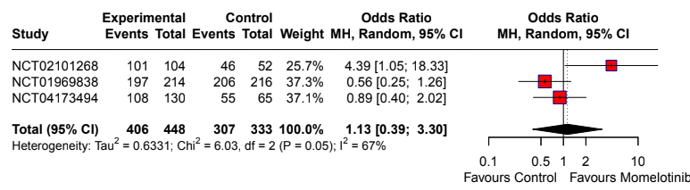
Suppl 9b. Forest Plot of Dizziness. NCT identifiers correspond to: NCT02101268 – SIMPLIFY-2; NCT01969838 – SIMPLIFY-1; NCT04173494 – MOMENTUM.
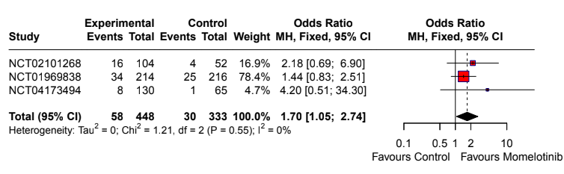
Suppl 9c. Forest Plot of Nausea. NCT identifiers correspond to: NCT02101268 – SIMPLIFY-2; NCT01969838 – SIMPLIFY-1; NCT04173494 – MOMENTUM.
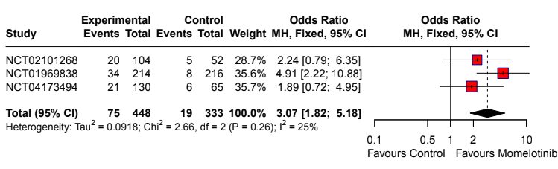

Suppl 9d. Forest Plot of Adverse Events Leading to Discontinuation. NCT identifiers correspond to: NCT02101268 – SIMPLIFY-2; NCT01969838 – SIMPLIFY-1; NCT04173494 – MOMENTUM.
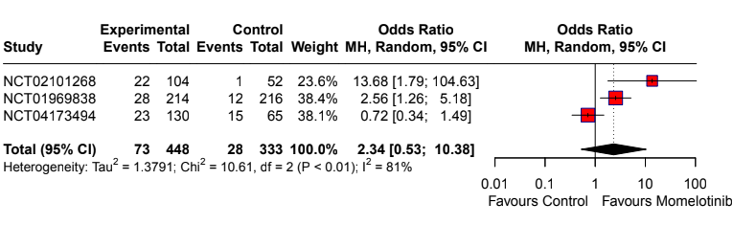

Suppl 9e. Forest Plot of Death Related to Drug. NCT identifiers correspond to: NCT02101268 – SIMPLIFY-2; NCT01969838 – SIMPLIFY-1; NCT04173494 – MOMENTUM.
